**Overall App Evaluation Report**

*Backbase Mobile Assignement*

*02-05-2020*

TABLE OF CONTENTS

1 Introduction 3

1.1 Purpose 3

2 OVERVIEW 3

3 Test Results 3

3.1 Link to the Last execution Test Report 3

3.2 Link to the Last execution Automation Report 3

4 Test cases details 3

*5* *Bugs details* 4

6 SuggEstED aCTIONS 4

7 RiskS 5

# Introduction

## Purpose

This Backbase Mobile Assignement Overall App Evaluation Report provides a summary of the application status.

# OVERVIEW

The native Android application shows a list of cities which you can search and when you choose a city the app shows a pin on a map. Then you can go back and repeat the process. After the test execution and the code revision some issues and improvements were detected, in the next sections you will be able to see them.

# Test Results

## [Link to the Last execution Test Report](02-Test%20Report%20Execution%20(02-05-2020).docx)

## [Link to the Last execution Automation Report](Automation%20Execution%20Report/index.html)

# Test cases details

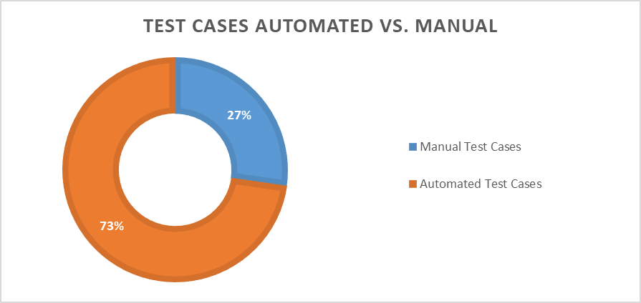

|  |  |  |
| --- | --- | --- |
| **TC ID** | **Scenarios** | **Is Automated** |
| [TC_0001](Test%20Cases/TC_0001.docx) | Verify that the user is able to search a city in the list using the fully name | Yes |
| [TC_0002](Test%20Cases/TC_0002.docx) | Verify results when the user search an unknown city in the list | Yes |
| [TC_0003](Test%20Cases/TC_0003.docx) | Verify that the cities are listed in ascending alphabetical order | No |
| [TC_0004](Test%20Cases/TC_0004.docx) | Verify that the searched cities are listed in ascending alphabetical order | Yes |
| [TC_0005](Test%20Cases/TC_0005.docx) | Verify that the user is able to scroll up and scroll down the list of cities | Yes |
| [TC_0006](Test%20Cases/TC_0006.docx) | Verify that the user is redirected to the map activity when a city is selected from the default list | Yes |
| [TC_0007](Test%20Cases/TC_0007.docx) | Verify that the user is redirected to the map activity when a searched city is selected | Yes |
| [TC_0008](Test%20Cases/TC_0008.docx) | Verify that the user is able to repeat the search process | Yes |
| [TC_0009](Test%20Cases/TC_0009.docx) | Verify that the user is able to interact with the map | No |
| [TC_0010](Test%20Cases/TC_00010.docx) | Verify that the user is able to search a partial city name in the list | Yes |
| [TC_0011](Test%20Cases/TC_00011.docx) | Verify that the map is displayed in blank when there is not internet connection | No |

# Bugs details

|  |  |  |  |  |
| --- | --- | --- | --- | --- |
| **ID** | **Title** | **% Occurrence** | **Severity** | **State** |
| [DF_0001](Bugs/DF_0001.docx) | The default list of cities is not ordered alphabetically | 100% | Med | Open |
| [DF_0002](Bugs/DF_0002.docx) | The filtered list of cities is not ordered alphabetically | 100% | Med | Open |
| [DF_0003](Bugs/DF_0003.docx) | The default list of cities is not fully displayed after the search field is deleted | 82% | Low | Open |
| [DF_0004](Bugs/DF_0004.docx) | The Map is not correctly displayed when a city is selected | 100% | High | Open |
| [DF_0005](Bugs/DF_0005.docx) | The list doesn’t display any result when the city and country name are used in the search | 100% | Med | Open |

# SuggEstED aCTIONS

1. Add unit test to verify if the list is ordered alphabetically.
2. Change listView by reciclerView, it allows us significantly improvement in performance
3. Migrate Gradle’s scripts to the new Gradle syntax:
   1. “compile” and “testCompile” keywords are deprecated
   2. Update target SDK and min SDK version
4. Define some KPA (Key performance indicator) would be useful to measure how the application is responding to the actions*.*
5. Incorporate a tool that allow us to execute this test in different cloud devices.
6. Automate test cases using tools that allow us to interact with the map.
7. Incorporate to the automation test the Spoon tool to run the tests on multiple devices simultaneously and see the results in a meaningful way.

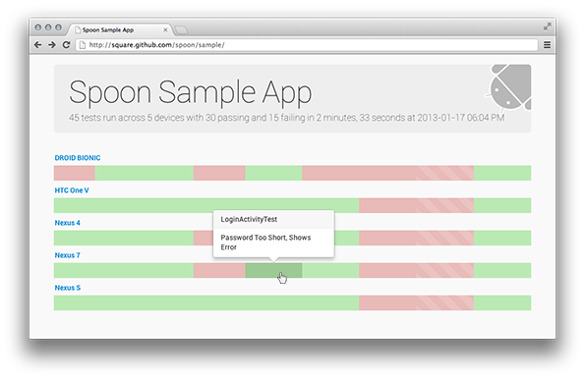

1. Incorporate some Test Tool Management would be useful to design test cases, track bugs, measure feature coverage, create test plans execution, capture requirements, inform other team-members about Testing progress etc.
2. Add screenshots or videos when the test is failed.

# RiskS

1. Performance issues could happen managing a View List with a lot of items.
2. If the SDK versions are updated, a list of users that use older devices can be lost.
3. In the project Google Maven repository was added and the Build Gradle version was updated from 2.1.2 to 3.4.2, it allows us to use androidTestImplementation and implement Espresso. We need to validate if it is a risk for the app.